**Chapter 1**

**Introduction**

1. **Background of the Study**

Radio controlled and Remote controlled where in the latter case the vehicles included are connected to their controller by a wire but common use of RC today refers to radio controlled cars where vehicles are controlled through wireless technology using a radio-frequency link. These radio controlled cars are small but complex pieces of machinery designed to fascinate and attract millions of people like me who admire cars and just simply can't live without them. Radio-controlled or R/C cars are self-powered model cars or trucks that can be controlled from a distance using a specialized transmitter. The term "R/C" has been used to mean both "remote controlled" and "radio controlled", where "remote controlled" includes vehicles that are connected to their controller by a wire, but common use of "R/C" today usually refers to vehicles controlled by a radio-frequency link. This article focuses on radio-controlled vehicles only.

We perform mainly four operations Left, Right, Up and Down but there is also have forward-right, forward left, backward-right and backward left to move the car in particular directions. We used a proximity sensor; a proximity sensor can detect objects without physical contact**.** This project involves controlling a radio controlled car using a computer as an interface. The project involves the use of both hardware and software. It is work as a system tool that depends on the parallel port. It is design for search and detective operation and it’s very good software and hardware project. The software is that chosen to be used in the project is Assembly Language. The hardware involves using a parallel port, a remote control car and a circuit to control the signal sent through the parallel port. With the software, the computer sends a signal from the parallel port to the transistor. The transistor closes the circuit between the ground and the positive side of the button switch. This is the exact same thing that happens when you press the button manually. So essentially, the computer is pressing the buttons for you. A proximity sensor often emits an electromagnetic field or beam and look for changes in the field. The object being sensed is often referred to as the proximity sensor's target. Different proximity sensor targets demand different sensors.

1. **Statement of the Problem**

The primary goal of this study is to determine the function of a PC based Radio Controlled Cars in producing different moves of the car to any particular directions. Specifically, this study will seek answers in the following questions:

1. What are the essential features of a PC based Radio Controlled Cars?
2. What are those particular module used in making a PC based Radio Controlled Cars?
3. How does a Radio Controlled Cars works?
4. What are the advantages and disadvantages of a PC based Radio Controlled Cars?
5. How does Assembly Language improved the program in making PC based Radio Controlled Cars?

**Objectives of the Study**

These are the following objectives that the researcher would like to achieve.

General Objective:

* The general objective of this study is to know the function of a PC based Radio Controlled Cars.

Specific Objective:

* To determine the essential features of a PC based Radio Controlled Cars.
* To familiarize the different module use to have a PC based Radio Controlled Cars.
* To be able to understand the work of a Radio Controlled Cars.
* To know the advantages and disadvantages of a PC based Radio Controlled Cars.
* To be able to know the use of an Assembly Language to improve our program to make PC based Radio Controlled Cars?

1. **Scope and Limitation of the Study**

This project is focus about PC-Based Radio Control Cars. This project also gave information about the parallel port in interfacing PC-Based Radio Control Car. This project is trouble to release the major parts of a PC-Based Radio Control Car. The project also gave its priority on knowing how manual and automatic mode functions in a Radio Control Car. This project is also an attempt to witness how convincing is a proximity sensor in passing obstacles in the race track. The project also focuses on the proper procedures to be done in successfully interfacing PC to Radio Control Car.

Remote control cars work to radio waves. On the electromagnetic spectrum, radio waves, they are pretty big, low energy and are not at all harmful. The important parts of the remote control car setup are the antennas. The transmission antenna on the remote sends a signal, via radio waves, to the car, which picks it up using its receiving antenna. How the radio waves travel from one antenna to another is called transmittance and lucky for us, air is very good at transmitting radio signals. But not all materials allow radio waves to travel through them. The result of your tests will depend on how well the antennas are covered and how thick the material is, but most importantly the type of material. Because of their internal structure, some materials, like cardboard and plastics, allow radio waves to travel into and through them, while others, like many metals, reflect the radio waves and therefore stop the transmission.

**Chapter 2**

**DATA PRESENTATION AND ANALYSIS**

1. **Block Diagram**

**MANUAL**

**PC**

**RELAY**

**TRANSMITTER**

**RECEIVER**

**DB25**

**AUTOMATIC**

1. **System Flow Chart**

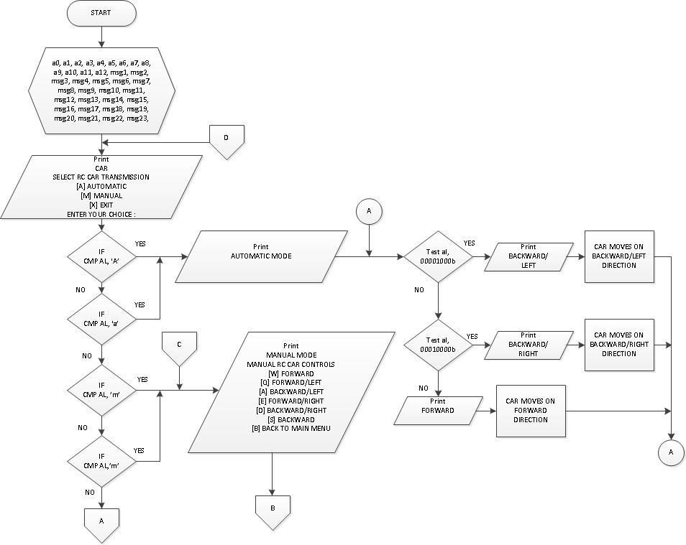

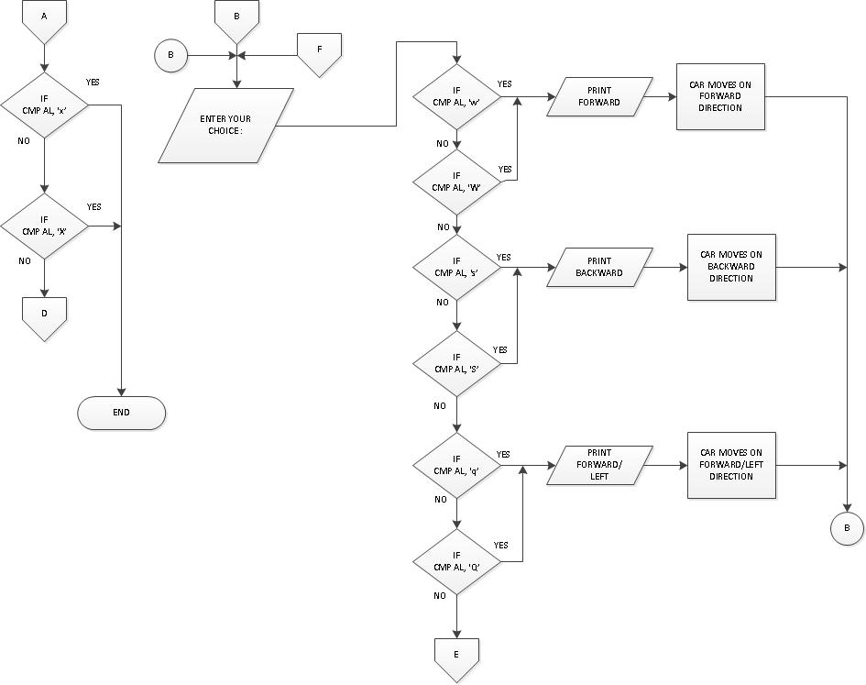

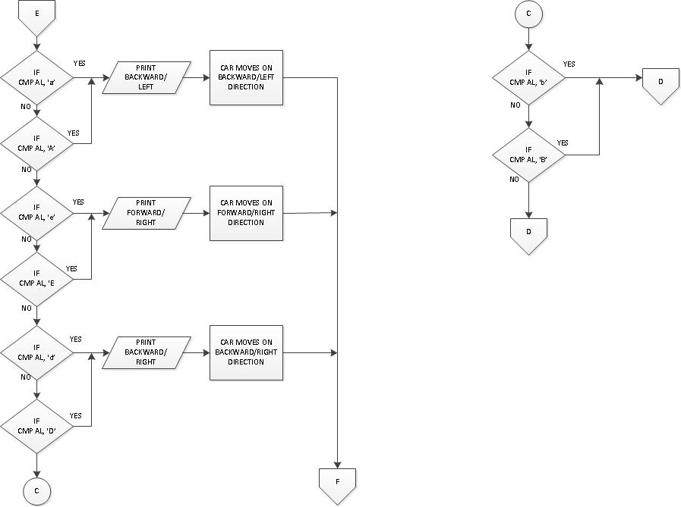

1. **Program Flow Chart**

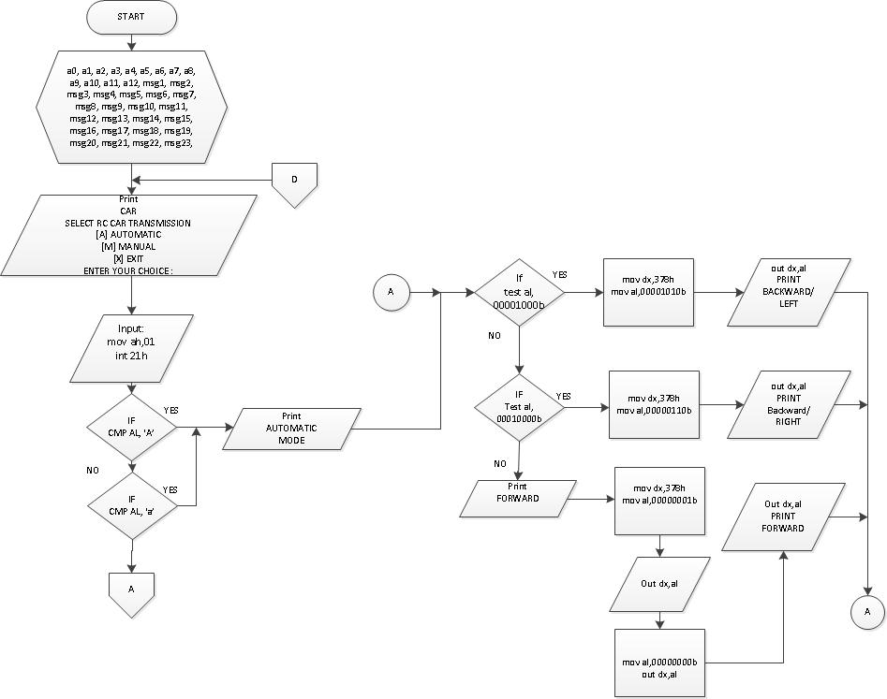

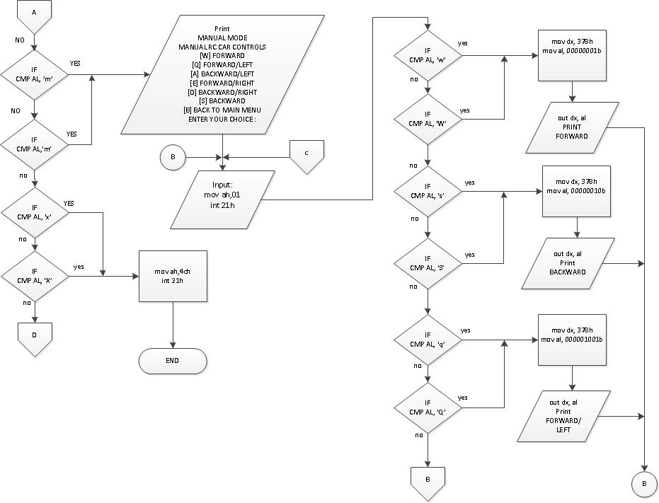

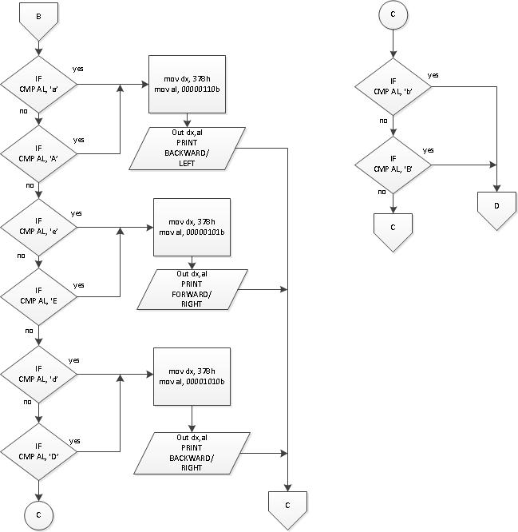

1. **Schematic Layout**

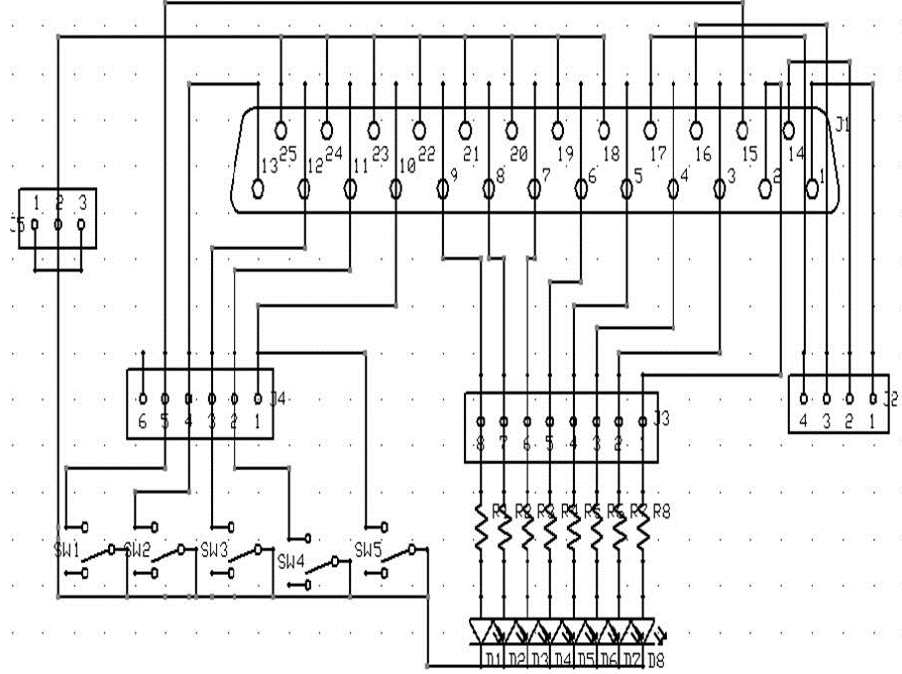

**Figure 1. Schematic Layout of DB25**

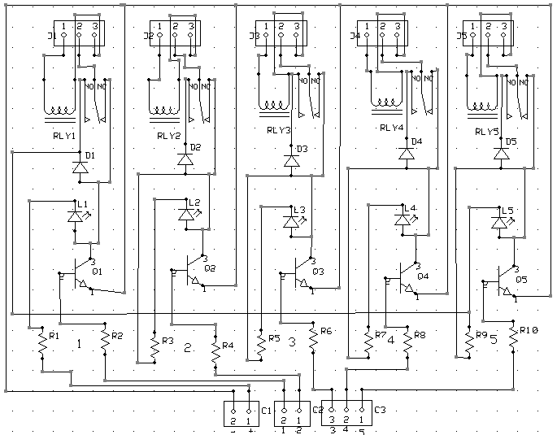

**Figure 2. Schematic Layout of Relay**

1. **PCB Layout**

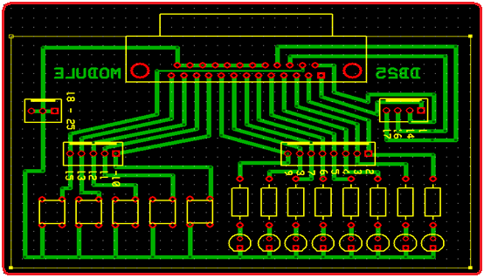

**Figure 3. PCB Layout ofDB25 Module**

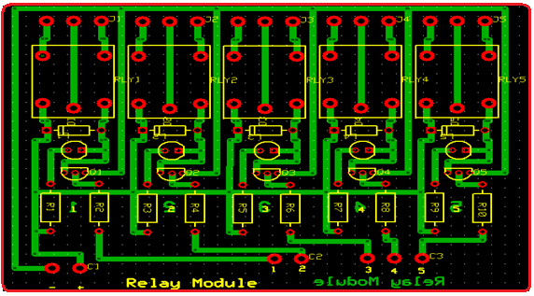

**Figure 4. PCB Layout of Relay Module**

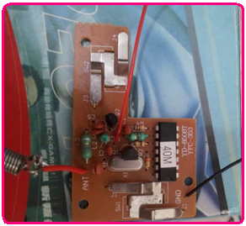 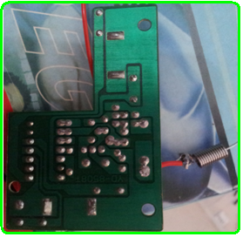

**Figure 6. Back View of the Transmitter (Automatic)**

**Figure 5. Front View of the Transmitter (Automatic)**

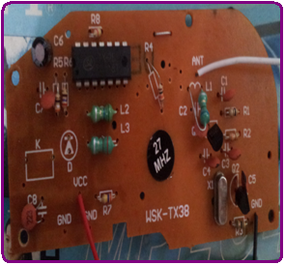 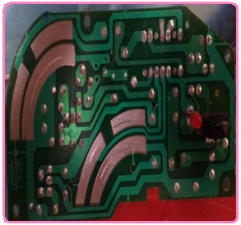

**Figure 7. Front View of the Transmitter (Manual)**

**Figure 8. Back View of the Transmitter (Manual)**

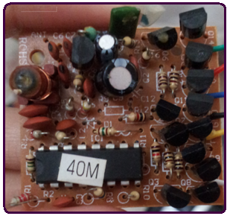 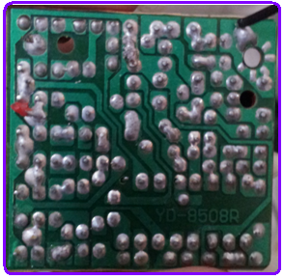

**Figure 10. Back View of the Receiver**

**Figure 9. Front View of the Receiver**

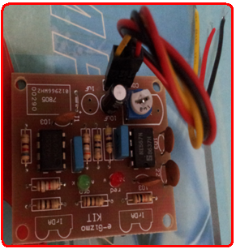 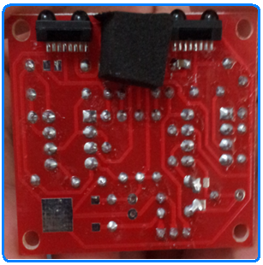

**Figure 12. Back View of the Proximity Sensor**

**Figure 11. Front View of the Proximity Sensor**

1. **Prototype**

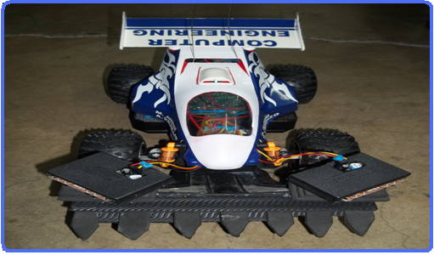

**FRONT VIEW**

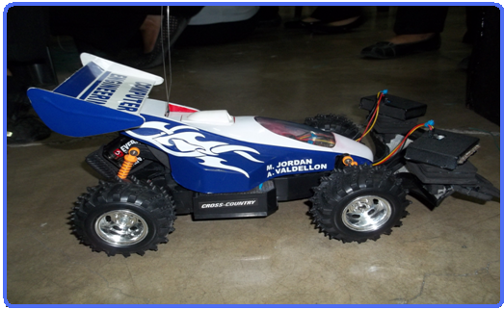

**RIGHT SIDE VIEW**

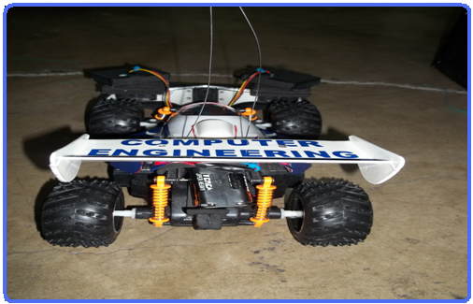 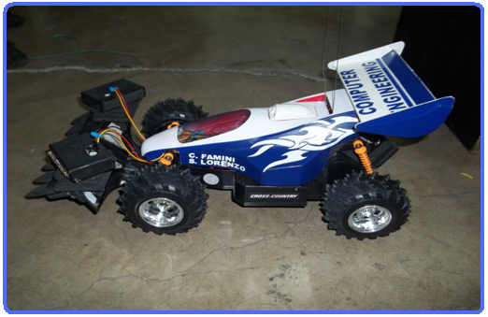

**BACK SIDE VIEW LEFT SIDE VIEW**

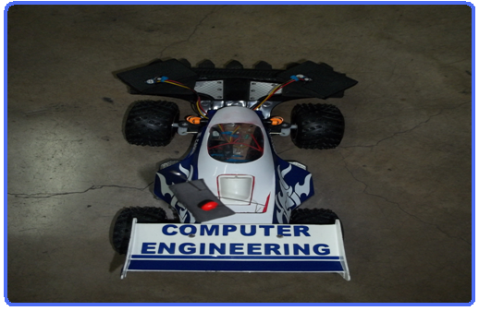

**TOP VIEW**

**Chapter 3**

**Summary, Conclusions and Recommendations**

1. **Summary**

In this project Computer Control RC Car is based on hardware and software. The project is a system tool which provides interfacing between computer and external hardware and system control the output of the parallel port by the software. Before, it was not possible. But now, with the technologies available, such as computer interfacing, and Radio Frequency wireless devices, this project can now put that idea into use. There are two parts to this project, the computer algorithm and the RC car.

Once the sensors detect something in its way, it sends a signal to the relay, which compares it to the existing data, and then puts the proper command out to the Radio Frequency transmitter. The Radio Frequency transmitter then analyzes the data and transmits it to the RC car to execute the proper functions needed. The algorithm sends a signal to the relay to activate it. When the Radio Control car receives the command, it will execute it.

In this project the main part is the parallel port through which we can connect the external hardware to the system and finally through the interface we send the signal to the parallel port to operate the car. By default the signal is not zero at the parallel port and it always high, so first we send zero signal to the parallel port and all pins of the port goes low then we give a high signal to the parallel port and the pin receive the high signal and then car moves forward. The car is a Remote object since it is not directly connected to our circuit. In the hardware we are using the parallel port to provide signal to the interface card so that it can transmit signals to the car and guide it to move in a particular direction. The parallel port is the most commonly used port for interfacing homemade projects. Parallel ports are easy to program and faster compared to the serial ports. But main disadvantage is it needs more number of transmission lines. Because of this reason parallel ports are not used in long distance communications. This port allows the input of up to 9 bits or the output of 12 bits at any one given time, thus requiring minimal external circuitry to implement many simpler tasks.

1. **Conclusion**

In the light of the findings of the study, the following conclusions were drawn.

The essential features of the PC based Radio Controlled Cars involves the use of both hardware and software. In The software is that chosen to be used in the project is Assembly Language. The hardware involves using a parallel port; the Parallel Port has three commonly used base addresses the 3BCh base address was originally introduced used for Parallel Ports on early Video Cards. This address then disappeared for a while, when Parallel Ports were later removed from Video Cards. They has now reappeared as an option for Parallel Ports integrated onto motherboards, upon which their configuration can be changed using BIOS.. In Assembly Language, it is a low level language that provides a kind of short hand notation called mnemonic for actual machine language instruction. We have TASM to make a program that will give us an output of different movement of RC cars.

In this project we have Relays, which are used where it is necessary to control a circuit by a low-power signal, or where several circuits must be controlled by one signal. Another is RF module comprises of an RF Transmitter and an RF Receiver. The transmitter/receiver pair operates at a frequency of 434 MHz an RF transmitter receives serial data and transmits it wirelessly through RF through its antenna connected at pin4. The transmitted data is received by an RF receiver operating at the same frequency as that of the transmitter. Next is, we also have DB25 Module, connector is an analog 25-pin plug of the D-Subminiature connector family.

1. **Recommendation**

In the light of the findings and conclusions of the study, the following recommendations are hereby presented for consideration.

1. The reader must have greater insight about the essential features of a PC based Radio Controlled Cars.
2. The reader must understand well the work of Radio Controlled Cars in producing different movements.
3. The user must aware familiar to the different module use to have a PC based Radio Controlled Cars.
4. The reader must knowledgeable in describing the advantages and disadvantages of PC based Radio Controlled Cars?
5. The user must aware about the Assembly Language as part of this project.

**Appendix**

1. **References**

* <http://hobbypartz.org/radio-controlled-cars.html>
* <http://en.wikipedia.org/wiki/Radio-controlled_car>
* ten.com.au/Remote_Controlled_Car.pdf

1. **Pictures**

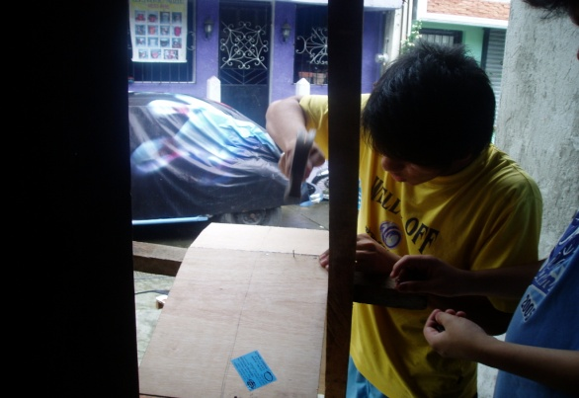

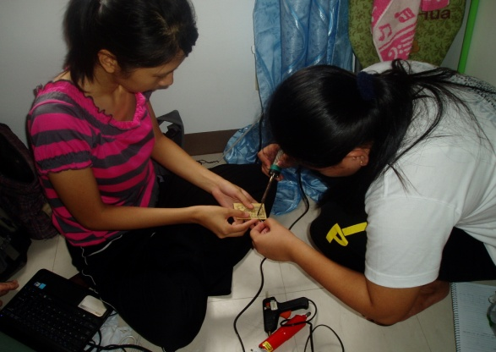

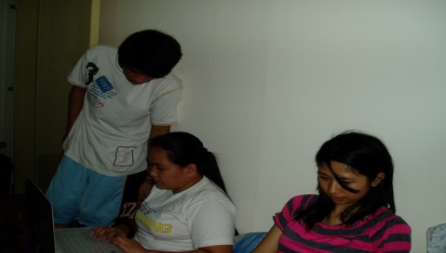

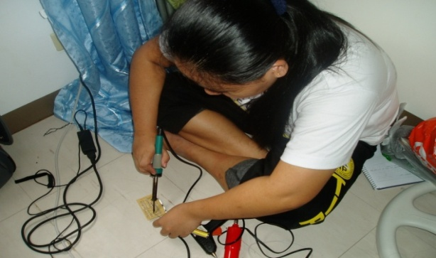

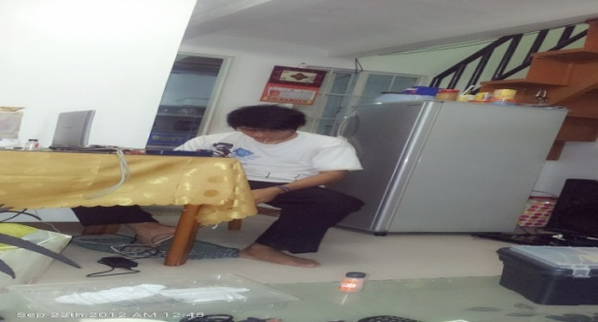

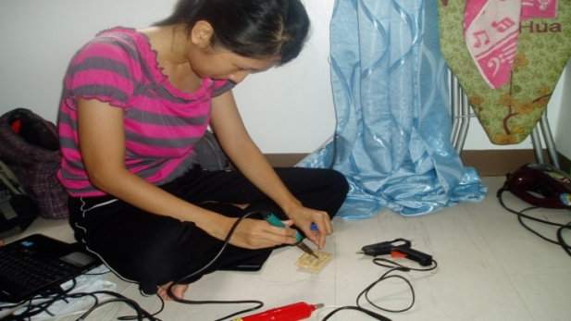

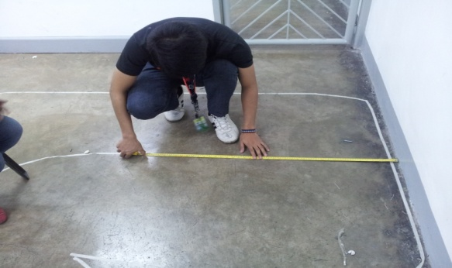

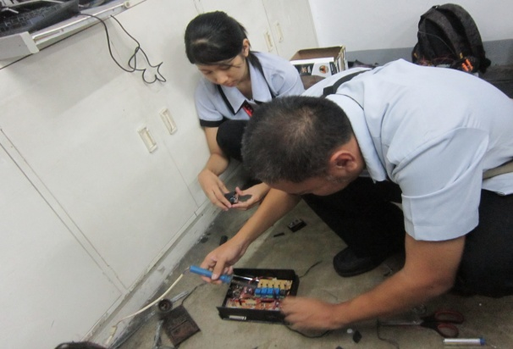

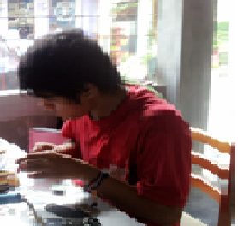

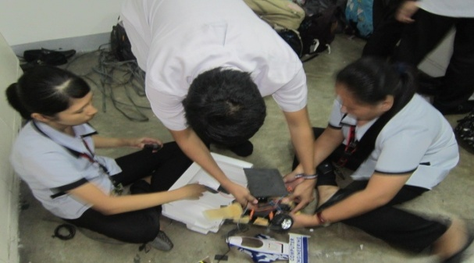

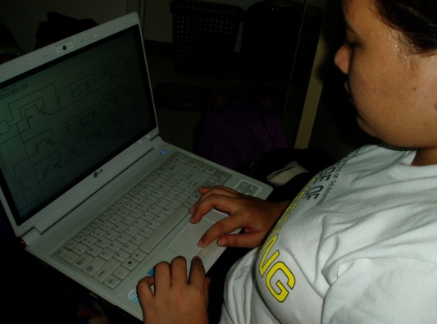

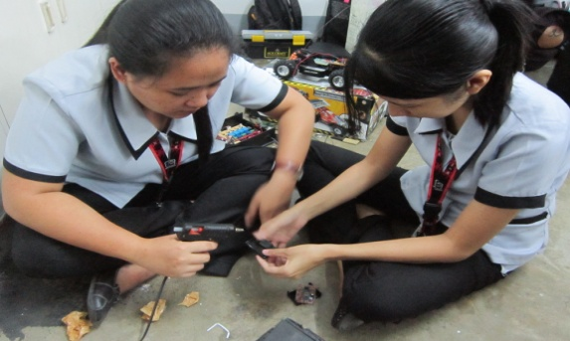

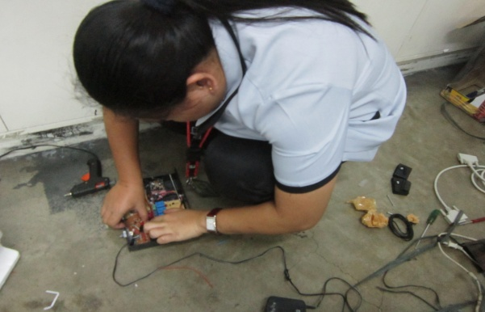

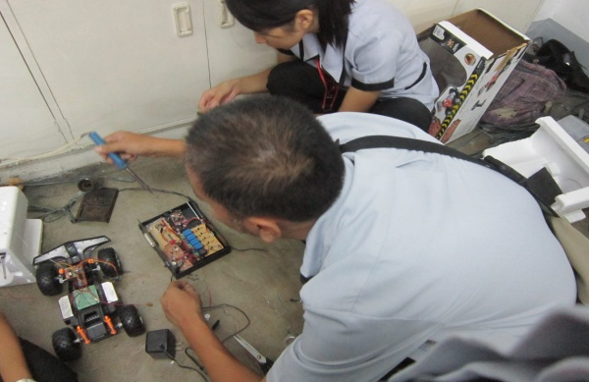

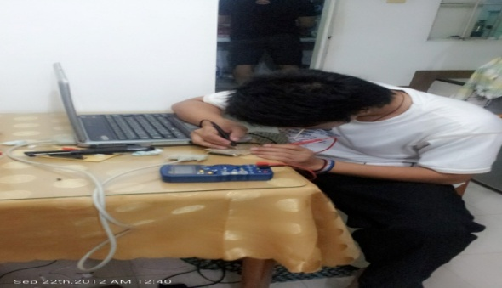

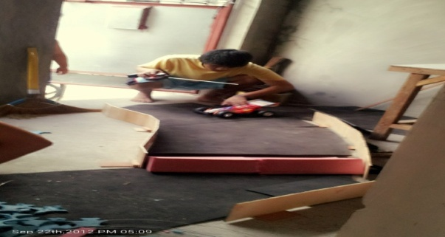

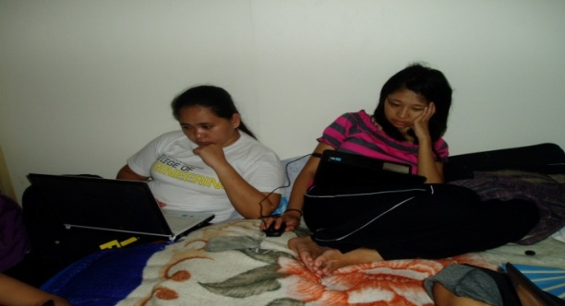

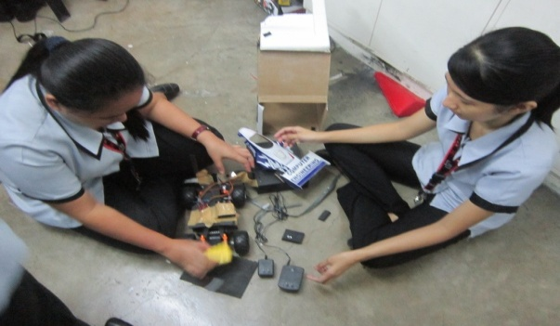

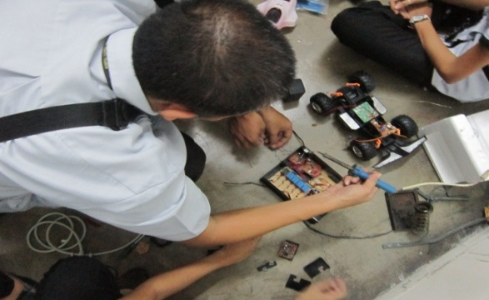

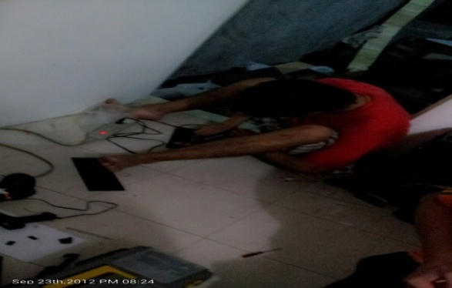

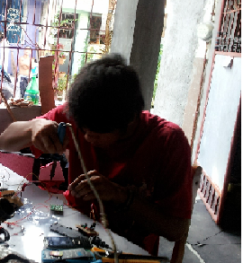

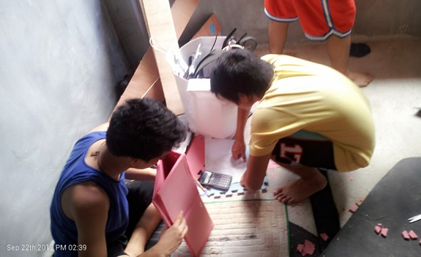

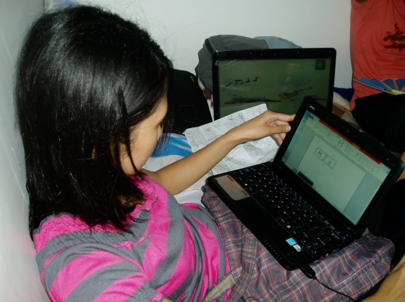

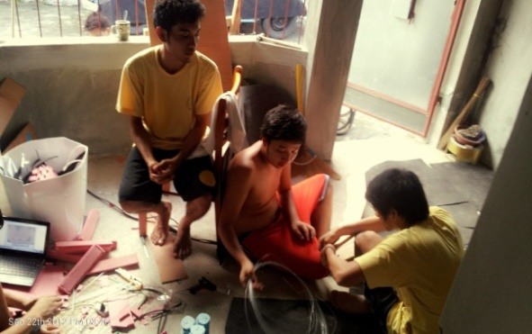

**Technological Institute of the Philippines**

**1338 Arlegui St., Quiapo, Manila**

**Computer Engineering Department**

**Project**

**(PC based Radio Control Car)**

**Rating**

**Famini, Catherine L.**

**Jordan, Michael George T.**

**Lorenzo, Serelyn Ira**

**Valdellon, Allan**

**CP433L1/CPE41FA1**

**05 October 2012**

**Technological Institute of the Philippines**

**1338 Arlegui St., Quiapo, Manila**

**Computer Engineering Department**

**Project**

**(PC based Radio Control Car)**

**Rating**

**Custodia, Karenn A.**

**De Torres, Arianne S.**

**Martinez, Cederic F.**

**Wong, Luzviminda R.**

**CP433L1/CPE41FA1**

**05 October 2012**

**Technological Institute of the Philippines**

**1338 Arlegui St., Quiapo, Manila**

**Computer Engineering Department**

**Project**

**(PC based Radio Control Car)**

**Rating**

**Aguilera, Janet G.**

**Almario, Angelica J.**

**Corpuz, Raymond**

**Tomas Jr., Renato P.**

**CP433L1/CPE41FA1**

**05 October 2012**